Supplementary material for:

A seed predator drives the evolution of a seed dispersal mutualism

Adam M. Siepielski*, Craig W. Benkman

*To whom correspondence should be addressed. E-mail: Adam.M.Siepielski@Dartmouth.edu

This file includes:
Supplementary material Table 1
Supplementary material Figures 1 and 2

Table 1. Principal component loadings of the nine limber pine cone and seed traits describing cone and seed structure and the amount of variation explained by the first two principal components (n = 210 trees).
 | Eigenvector
Trait | PC1 | PC2
___________________________________________________________________________
Cone length (mm) | 0.27 | 0.53
Cone width (mm) | 0.38 | 0.16
Cone mass (gm) | 0.36 | 0.41
Peduncle diameter (mm) | 0.33 | 0.08
Number of scales | -0.32 | 0.43
Proximal scale thickness (mm) | 0.41 | 0.41
Total number of seeds | -0.19 | 0.52
Seed mass (mg) | 0.27 | -0.03
Seed coat thickness (mm) | 0.40 | -0.16
Percent variation explained: | 48.7 | 19.20
___________________________________________________________________________

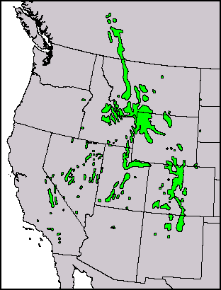
RM
SC
GB
TR
SP
JM
PI
VE
N
RF
MM

Figure 1. The distribution of limber pine (gray; based on Little [1971]), the occurrence of red squirrels (absent from south of the dashed line [mostly Nevada]), and the location of study sites. Study sites from west to east: Toiyabe Range (TR), Ruby Mountains† (RM), Schell Creek Range† (SC), Mt. Moriah† (MM), Great Basin National Park (GB), Pinedale (PI), South Pass† (SP), Jelm Mountain† (JM), Red Feather Lakes (RF), and Vedauwoo† (VE). †Denotes sites where seed-tracking experiments were conducted.

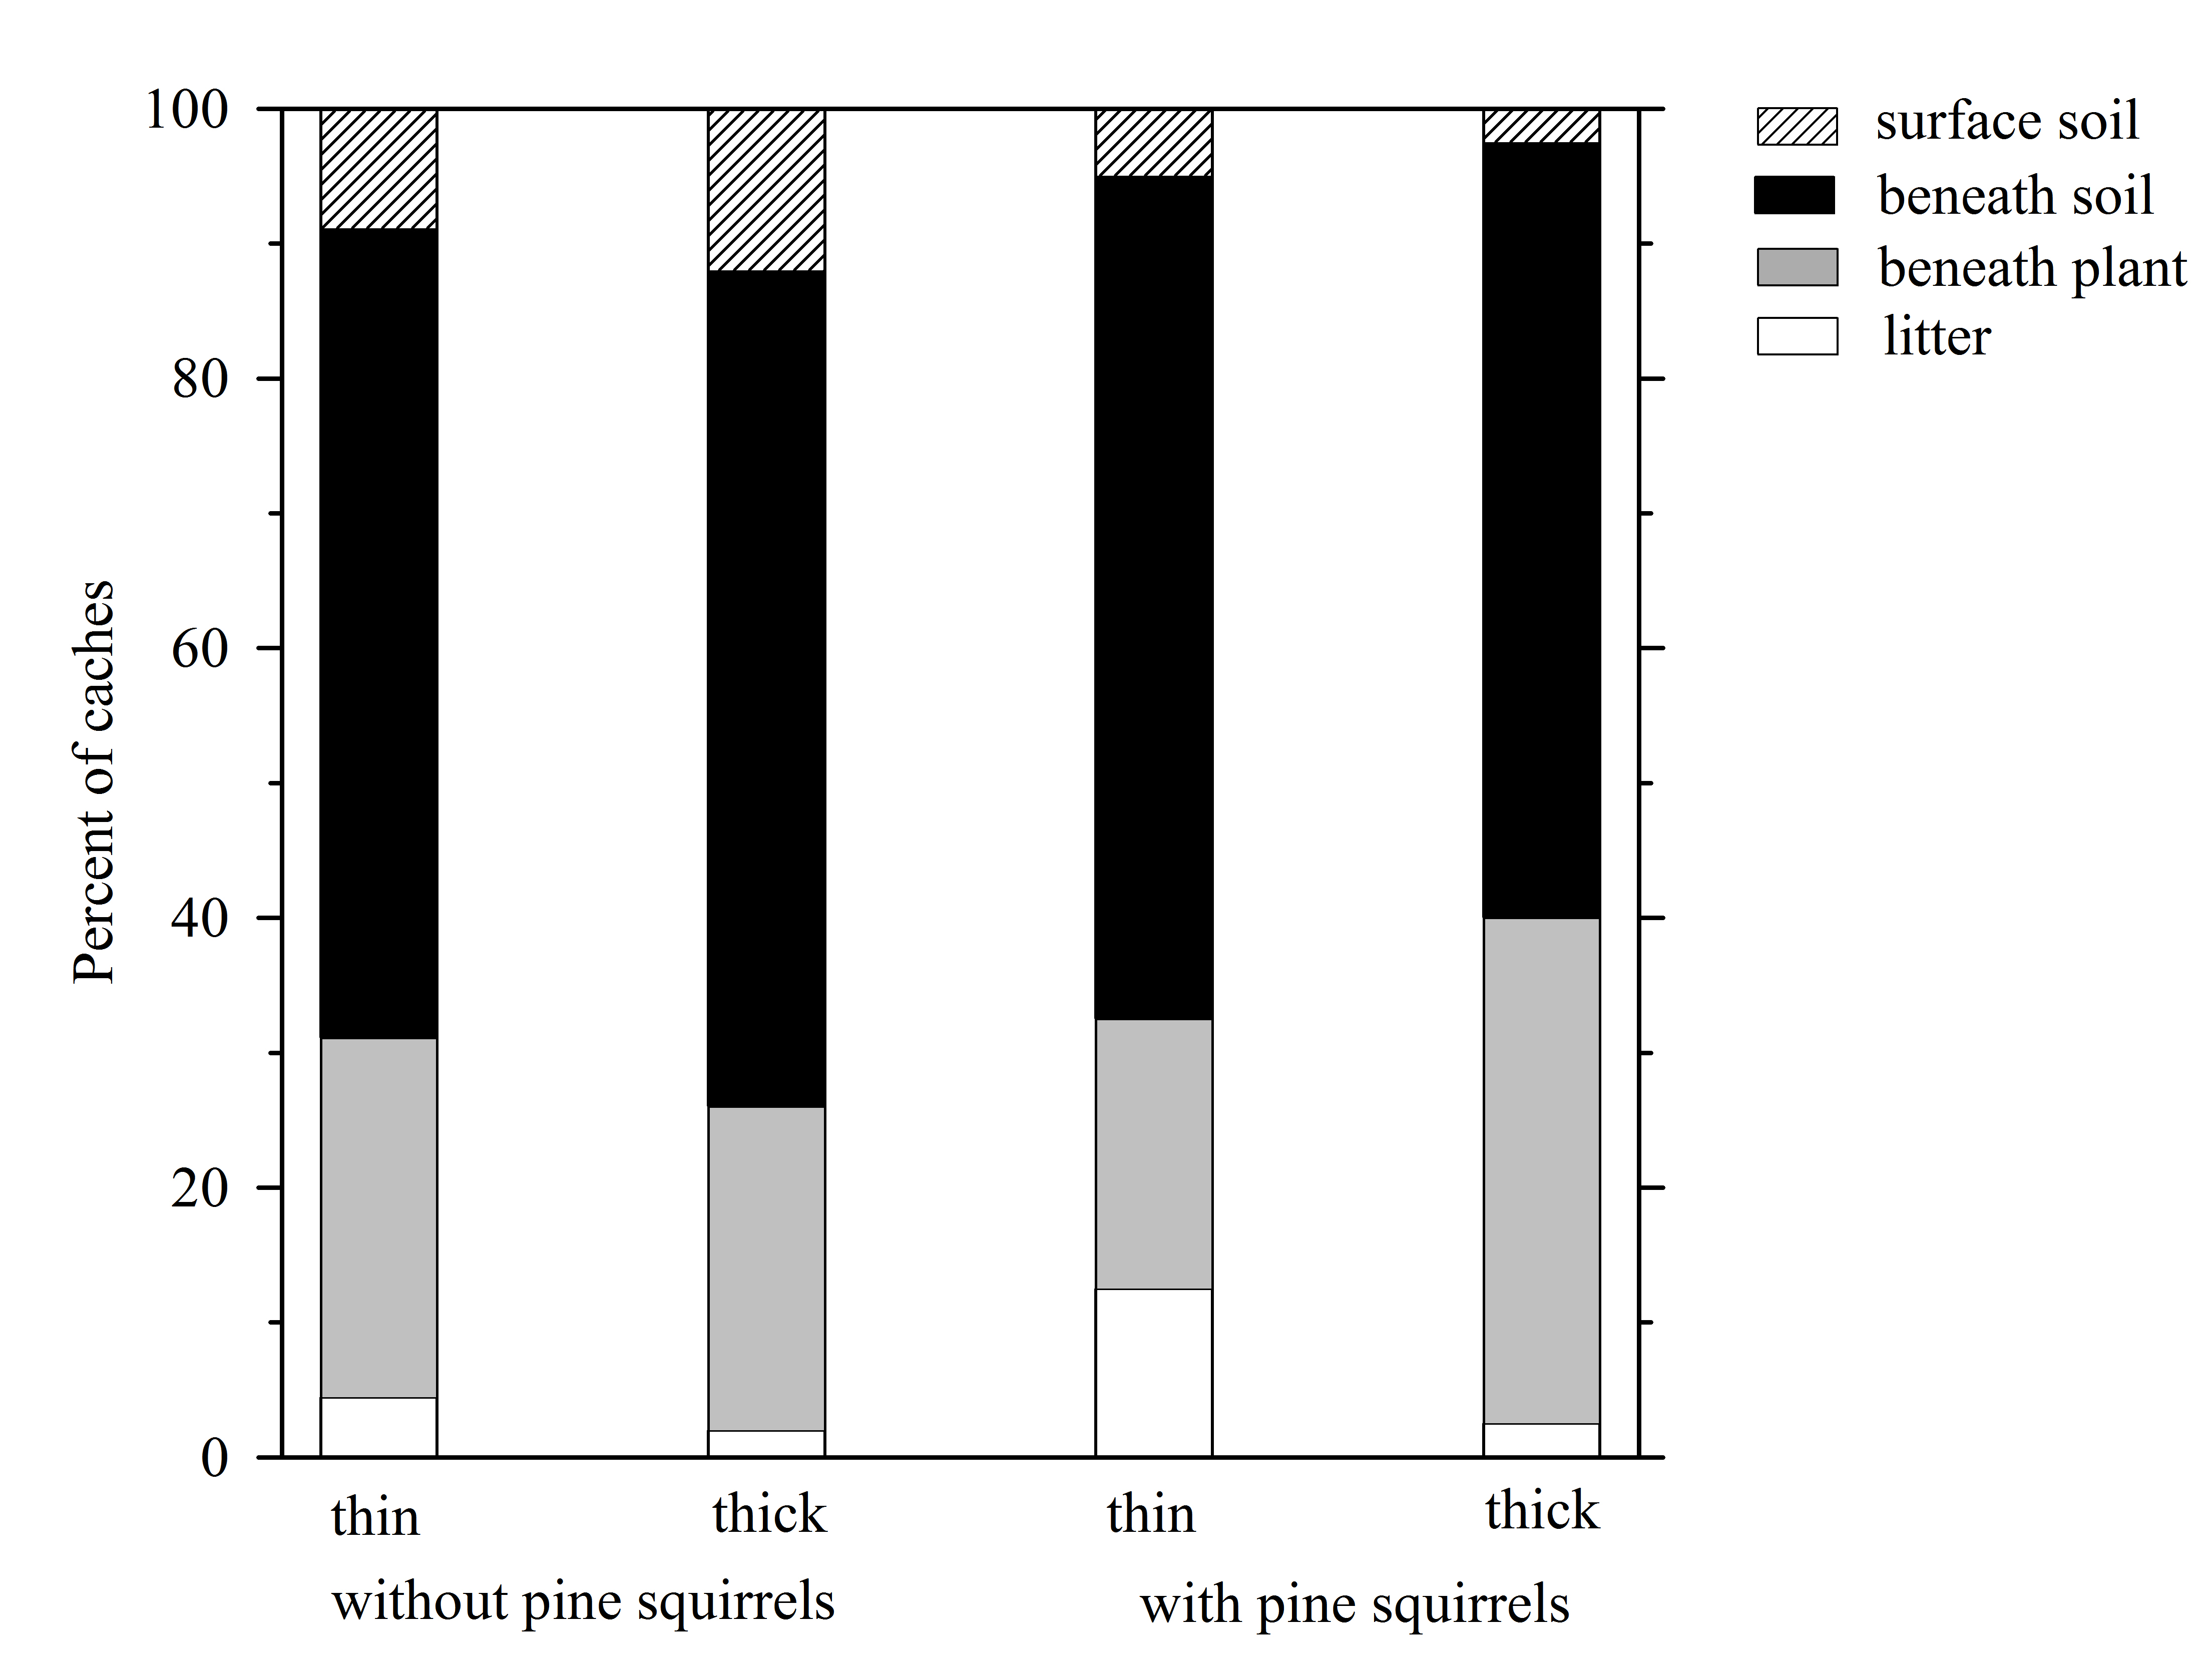

Figure 2. Variation in substrates used by rodents when caching limber pine seeds with thin and thick seed coats among areas without and with pine squirrels.

